|  |  |  |  |  |
| --- | --- | --- | --- | --- |
| Year  9 | | Mathematics Test  Congruence | | Non Calculator |
| Short Answer Section | Name : ______________________ | |
|  | Write all working and answers in the spaces provided on this test paper. | | | |
| 1. | A pentagon *PQRST* is shown.  One vertex has been translated according to the arrow.  Draw a congruent pentagon by completing the translation of the other vertices. | | | |
| 2. | A quadrilateral *EFGH* is shown.  Draw a congruent quadrilateral by reflecting in the interval AB  . | | | |
| 3. | A trapezium *GHIJ* is shown.  Draw a congruent trapezium by rotating through 90o about *R* in a clockwise direction.  . | | | |
| 4. | A rectangle has it diagonals drawn in, and the midpoints of the longer sides are joined.  List all of the congruent triangles formed.  ..........................................................................................................................................................    .......................................................................................................................................................... | | | |
| 5. | What does the abbreviation AAS mean in relation to congruent triangles?  ..........................................................................................................................................................    .......................................................................................................................................................... | | | |
| 6. | Which of the conditions AAS, RHS, SAS or SSS could be used to show congruence of triangles PQR and RSP?  .................................................................... | | | |
| 7. | Complete the missing information in the congruence proof below: | | | |
| 8. | Complete the reasons in the congruence proof below: | | | |
| 9. | Complete the congruence proof below. | | | |
| 10. | Complete the congruence proof below. | | | |

|  |  |  |  |  |
| --- | --- | --- | --- | --- |
| Year  9 | | Mathematics Test  Congruence | | Non Calculator |
| Multiple Choice Section | Name : ______________________ | |
|  | Mark all your answers on the accompanying multiple choice answer sheet, not on this test paper. You may do any working out on this test paper. Calculators are allowed for this section. | | | |
| 1. | Which of the congruence tests is sufficient to prove that  ?  A. (SSS) B. (SAS) C. (AAS) D. (RHS) | | | |
| 2. | *ABCD* and *EFCG* are congruent kites.  Which statement is not true?  A.  B.  C.  D. | | | |
| 3. | *PQR* is an isosceles triangle.  *QS* is drawn perpendicular to *PR*.  Which of the congruence tests is sufficient to prove that  ?    A. (SSS) B. (SAS) C. (AAS) D. (RHS) | | | |
| 4. | Figure 1 could be transformed to figure 2 by:   1. An enlargement. 2. A reflection 3. A rotation. 4. A translation. | | | |
| 5. | Which of the congruence tests is sufficient to prove that  ?  A. (SSS) B. (SAS) C. (AAS) D. (RHS) | | | |
| 6. | Which triangles are congruent ?  A. *I* and *II* only. B. *I* and *III* only.  C. *II* and *III* only. D. *I, II* and *III*. | | | |
| 7. | *LMNO* is a parallelogram with diagonal *LN* drawn..  Which of the congruence tests is sufficient to prove that *LMN**NOL* ?    A. (SSS) B. (SAS) C. (AAS) D. (RHS) | | | |
| 8. | Which triangle is congruent to  A. B.  C. D. | | | |
| 9. | The diagonals of quadrilateral *UVWX* are drawn, with the longer bisecting the shorter at right angles.  Which of the congruence tests is sufficient to prove that  ?    A. (SSS) B. (SAS) C. (AAS) D. (RHS) | | | |
| 10. | Which statement is true?  A. Triangle *I* is congruent to triangle *II*.  B. Triangle *III* is congruent to triangle *IV*.    C. Triangle *I* is congruent to triangle *IV* and triangle *II* is congruent to triangle *III*.  D. Triangle *I* is congruent to triangle *III* and triangle *II* is congruent to triangle *IV*. | | | |

|  |  |  |  |  |  |
| --- | --- | --- | --- | --- | --- |
| Year  9 | | | Mathematics Test  Congruence | | Non Calculator |
| Longer Questions | Name : ______________________ | |
|  | Write all working and answers in the spaces provided on this test paper.  Calculators are allowed for this section. | | | | |
| 1. | Complete the congruence proofs below, showing all required reasoning. | | | | |
|  | (a)  marks | …………………………………….  …………………………………….  …………………………………….  …………………………………….  ……………………………………. | | | |
| (b)  marks | …………………………………….  …………………………………….  …………………………………….  …………………………………….  ……………………………………. | | | |
| (c)  marks | …………………………………….  …………………………………….  …………………………………….  ……………………………………. | | | |

|  |  |  |  |
| --- | --- | --- | --- |
| Year  9 | Mathematics Test  Congruence | |  |
| Multiple Choice  Answer Sheet | Name : ______________________ | |

Completely fill the response oval representing the most correct answer.

1. A B C D

2. A B C D

3. A B C D

4. A B C D

5. A B C D

6. A B C D

7. A B C D

8. A B C D

9. A B C D

10. A B C D

|  |  |
| --- | --- |
|  | Mathematics Test  Congruence |
| Answer Sheet |

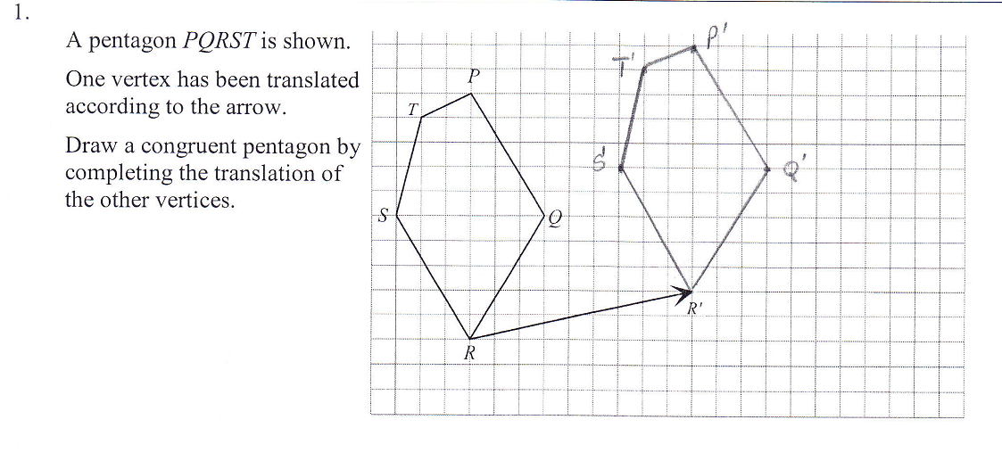

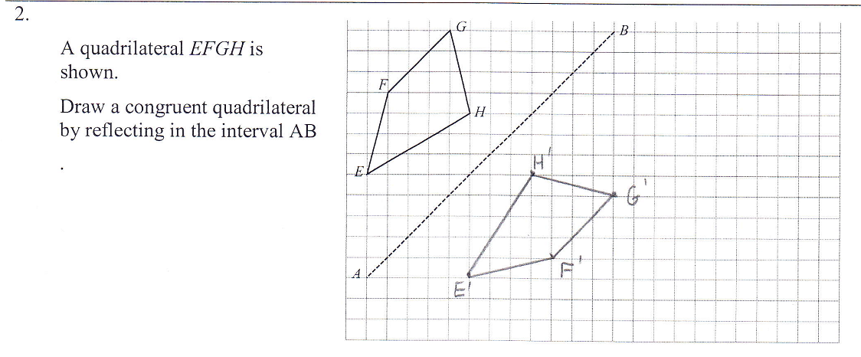

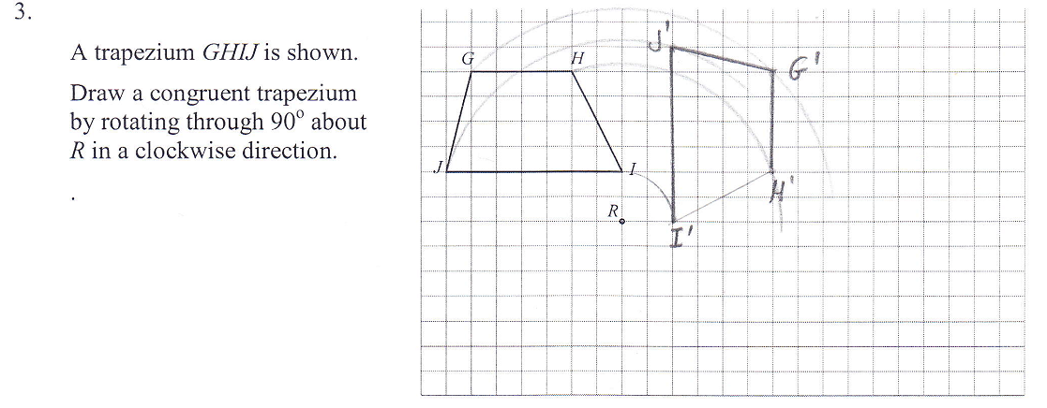

4. Triangles A, B D and E are congruent and triangles C and F are congruent.

5. Two angles and a side in one triangle are respectively equal to two angles and a corresponding side in the second triangle.

6. SAS

|  |  |
| --- | --- |
| 7. | Complete the missing information in the congruence proof below: |
| 8. | Complete the reasons in the congruence proof below: |
| 9. | Complete the congruence proof below. |
| 10. | Complete the congruence proof below. |

|  |  |
| --- | --- |
| Multiple Choice | |
| 1 | B |
| 2 | C |
| 3 | D |
| 4 | C |
| 5 | A |
| 6 | B |
| 7 | C |
| 8 | C |
| 9 | B |
| 10 | D |

|  |  |
| --- | --- |
|  | Longer Answers |
|  |  |
|  |  |